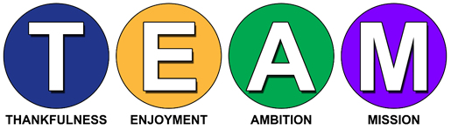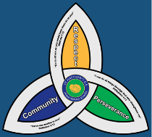**I

**Newsletter Spring Term 2024-2025**

|  |  |
| --- | --- |
| **Meet our new SEND Governor**  Mark Austin | My name is Mark Austin and I’ve recently been appointed to the Governing Body at St. Mathew’s and I’m Link Governor for SEND. I retired from teaching in 2021. My last post was Deputy Head and for a time Head of School of a large 800 placed primary school with a nursery provision in East London. As part of this role I led on Inclusion, SEND, Safeguarding and Teaching and Learning and oversaw one of London’s largest autistic provisions. I have also led on SEND and Inclusion in both Cheshire and Northampton. I have worked in Teacher Training with a couple of universities and in London also trained Primary and Secondary teachers in Safeguarding, SEND and Teaching and Learning. Telford is my hometown and although my career took me away from Telford, when I retired, I was happy to move back to Wellington where I now reside.  I am also a Governor of four other Telford and Wrekin schools covering Primary, Secondary and Special. It is a delight to have joined St. Matthew’s Governing Body. I have been made feel very welcome by all and I’m very much looking forward to getting to know St. Mathew’s and having the opportunity to meet and work with the children, staff, fellow Governors and parents. |

[10by10 adventure card VADO for download.pdf](https://content.govdelivery.com/attachments/UKTW/2025/04/01/file_attachments/3215354/10by10%20adventure%20card%20VADO%20for%20download.pdf)

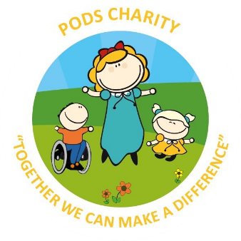

PODs have some amazing events over the Easter holidays, check out their website-

<https://www.podstelford.org/>



**SEND Local Offer**

The Telford and Wrekin local offer aim to bring together useful information across education, health, and

social care within one website. You can find information, advice and guidance across a range of local service

providers who support children and young people with Special Education Needs and Disabilities (SEND).

Telford and Wrekin Local offer – [SEND - Local offer (telfordsend.org.uk)](https://www.telfordsend.org.uk/site/index.php)

www.telfordsend.org.uk/site/index.php



**School Website**

Please visit the school website SEND section to find our School SEND Policy and information regarding how pupils with SEND needs are supported in school.

St Matthews CofE Primary – [SEND | St Matthew's Primary](https://www.stmatthewscofe.com/parents/send)

**Contact details**

|  |  |  |  |
| --- | --- | --- | --- |
| St Matthew’s SEND Team | 01952 386260  01952 386274 | Family Connect | 01952 385385  [www.telford.gov.uk/info/20223/familyconnect](http://www.telford.gov.uk/info/20223/familyconnect) |
| Mrs L. Burns  SENCo | Laura.burns@taw.org.uk | Information Advice Support Service | 01952 457176  [www.telfordsendiass.org.uk](http://www.telfordsendiass.org.uk/) |
| PODs - Parents Opening Doors | 01952 271532  [www.podstelford.org/](https://www.podstelford.org/) | SEND Telford | [www.telfordsend.org.uk/site/index.php](https://www.telfordsend.org.uk/site/index.php) |

**Wellbeing and Mental Health – Parent Signposting**

|  |  |  |
| --- | --- | --- |
| **Bee U**  Image result for Bee U emotional health and wellbeing | All pupils | Bee U is another service that consists of 4 organisations (The Children’s Society, Kooth, Healios and Midlands Partnership NHS Foundation Trust) who deliver emotional health and wellbeing services across Shropshire and Telford & Wrekin. New drop-in and online services are available as well as Young People and Families Mental Health Service (previously CAMHS) to help you with; getting advice, getting help, getting more help, getting risk support  [**https://beeu.org.uk/**](https://beeu.org.uk/) |
| **KOOTH**  Image result for KOOTH | 11 years+ | A free, safe and anonymous place for young people to find online support and counselling. Kooth has a team of professionals who aim to provide early response to emotional wellbeing as well as emerging mental health needs via our online platform and counselling sessions. |
| **Young Minds**  Image result for Young Minds | All pupils | Young Minds is the UK’s leading charity fighting for children and young people's mental health. They work to support parents of children and young adults with mental health issues. The helpline provides support and advice to parents and carers worried about the emotional wellbeing or behaviour of a young person in their care with confidential, expert advice.  [**https://youngminds.org.uk/**](https://youngminds.org.uk/) |

