PE Funding Evaluation Form

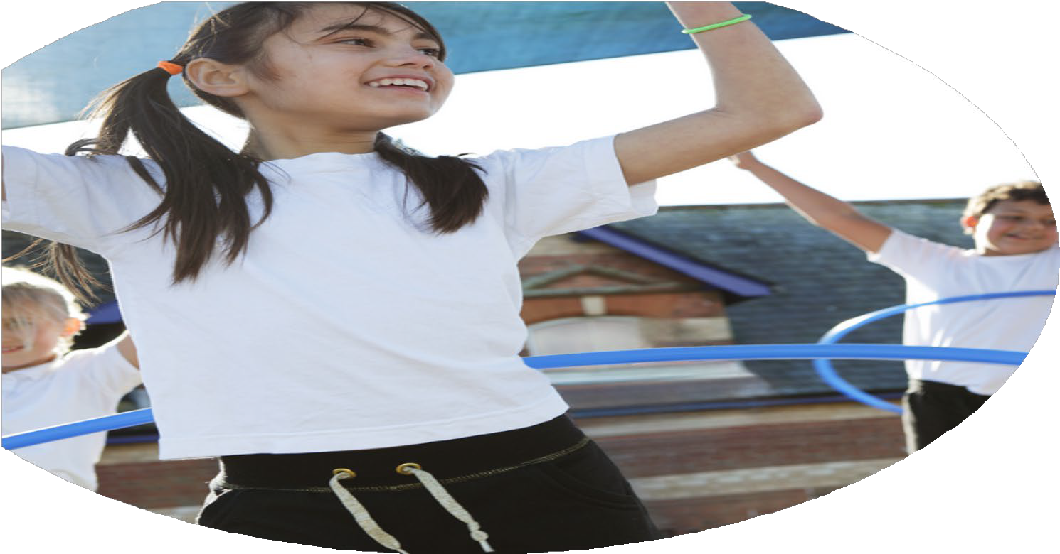

**2024-2025 REVIEW**



St. Matthew’s C.E. Primary School and Nursery Centre

**Commissioned by Created by**

Images courtesy oSt. Matthew’s CE (Aided) Primary School and Nursery Centre

*‘I can do all things because Christ gives me strength’ Philippians 4:13*

f Youth

Sports Premium Spending for the academic year 2024-2025

Swimming Data

|  |  |
| --- | --- |
| **Meeting national curriculum requirements for swimming and water safety** | Swimming for KS 2 will take place in the Summer term 2025  12 pupils (29%)  18 pupils (44%)  12 pupils (29%)  No |
| What percentage of your current Year 6 cohort swim competently, confidently and proficiently over a distance of at least 25 metres? |
| What percentage of your current Year 6 cohort use a range of strokes effectively [for example, front crawl, backstroke and breaststroke)? |
| What percentage of your current Year 6 cohort perform safe self-rescue in different water-based situations? |
| Schools can choose to use the Primary PE and Sport Premium to provide additional provision for swimming but this must be for activity **over and above** the national curriculum requirements. Have you used it in this way? |

**PE Funding Evaluation Form**

The PE and sport premium is funding for school’s to spend on helping your pupils be more healthy and active.

You should use it the PE and sport premium make sustainable improvements to the PE, sport and physical activity you provide, such as:

* Funding high-quality PE and sport for at least 2 hours a week
* Providing a wide range of extracurricular sport and competitive opportunities
* Providing or improving equal access to sport for boys and girls

The DfE also identifies 5 key priorities for improvement:

* Increasing all staff’s confidence, knowledge and skills in teaching PE and sport
* Increasing engagement of all pupils in regular physical activity and sport
* Raising the profile of PE and sport across the school, to support whole school improvement
* Offering a broader and more equal experience of a range of sports and physical activities to all pupils
* Increasing participation in competitive sport

**Spending the grant**

The PE and sport premium funding must:

* Build capacity or capability within your school, to ensure improvements benefit pupils joining in future years
* Develop or add to the PE, physical activity or sport activities you already offer

## **What the PE and sport premium cannot be used for:**

Funding must not be used for:

* capital expenditure, except for goods below the de minimis value (the threshold limit value set for purchases) – items above this limit would be recognised as an asset on the school’s balance sheet
* employing coaches or specialist teachers to cover planning preparation and assessment arrangements (this should be funded from the school’s core staffing budgets)
* teaching the minimum requirements of the national curriculum or, for academies, the existing PE curriculum (teaching the curriculum should be funded through the school’s core funding)
* staff salaries – for example, using your premium funding allocation to employ someone whose role is to specifically administer the PE and sport premium, or to use your entire funding allocation to employ someone that is responsible for arranging and running PE, sport or activity sessions
* buying services that will be delivered or used in following academic years (this includes paying for invoices and subscriptions in advance)
* buying staff PE kit

The 5 key indicators will be used when planning actions.

PESSPA stands for physical education, school sport and physical activity and includes PE lessons, school games events and competitions, sport leadership, extra-curricular clubs and enrichment.

|  |
| --- |
| **Key Priorities and Planning** |

**Actual received - £18,370**

|  |  |  |  |  |
| --- | --- | --- | --- | --- |
| **Action** | **Key indicator to meet** | **Cost linked to the action** | **Impacts** | **Next steps** |
| **To increase the participation and engagement of all children across the school in regular physical activity.**  Positive Play activities to take place at lunchtimes for 1 hour. A range of activities to be provided to encourage physical activity.  Positive Play equipment to be renewed each term, taking on board pupil voice.  Peer Buddies and Lunchtime staff to receive training to support physical activities at lunchtime.  A range of sports clubs to be provided free to attend to encourage uptake.  PSHE sessions to be delivered about health, well-being and the importance of being physically fit and healthy.  Year 6 participation in outdoor adventurous residential subsidised.  Energise (Sports England, T&W LA and NHS)  Physical health, mental health, healthy eating, community.  Activities for KS2 children and community. On-going plan throughout the year.  Ambition/inspiration  Being healthy, career, questionnaire, fitness tests.  ActivKids  Bikeability – Year 5 and 6.  Wild Tribe (EYFS) & outdoor equipment | 2,3,4 | Staffing for After School sports clubs Provision – £4,000  Sports Equipment for lunchtime £1,500  Resources - £5,000  Training of Peer Buddies and Lunchtime staff by Sports Coach and Pastoral Lead  £1,000  Lessons on health and participation to be delivered through Jigsaw materials.  Arthog subsidised for PPG children - £389  Cost – Free.  12 Year 5 pupils - £12.  £2,000 | After School Clubs available for pupils 4x per week.  Number of pupils attending clubs:  Autumn 1 – 85 Autumn 2 - 99 Spring 1 - 100 Spring 2 - 148 Summer 1 – 119  Pupil voice was completed at the end of Spring 1 to ask pupils which after school sports clubs they would like in school. Pupil numbers increased.  Lunchtime equipment has been implemented for both KS1 and KS2 pupils.  Positive play equipment has been used on the playgrounds during lunchtime. SLT and Pastoral Manager have supervised equipment being used on the playground. This has had a positive impact on behaviour and social interactions during lunchtimes.  PSHE (Jigsaw) lessons taught across the whole school – Improving pupils’ understanding of being keeping physical active and being healthy.  All KS2 attended Energise event @Telford Tennis Centre on 9th April 2025. 160 pupils.  Pupils participated in a range of physical activities, developing awareness of keeping active and looking after ourselves.  Sessions were carried out with Nursery and Reception – one morning or afternoon a week. This has improved communication and language skills. | Continue to target provision for girls and SEND across lunchtime and after school clubs.  A wider range of sporting competitions need to be accessed and participated in.  Continue use of pupil voice and peer buddies to provide clubs and activities that children would like. |
| To provide Continuous Professional Development **(CPD):**  To purchase new PE scheme of work to develop high quality teaching and learning. To review assessment procedures and progression maps. (Get Set 4 PE)  Training for Teachers who teach PE (Staff voice to be collected by subject leader).  Participation in local PE network meetings  Level 5 PE course for Sports Coach. | 1,3 | £700 (yearly subscription)  PE network meetings x 3 a year £116. Not Completed.  £1,300 | New PE curriculum has been implemented across the whole school – GET SET 4 PE. Curriculum maps have resulted in greater progression being seen for pupils’ journey through the school.  Release for subject leader – 3 sessions (£500)  Sports coach attended PE courses enabling a greater understanding of building progression throughout the school. | Lesson observations and pupil voice to see positive impact of new curriculum.  Provide more CPD for teachers who are leading PE lessons.  Subject Leader to meet with local school partnership lead to arrange further competitions to engage more pupils. |
| **Competitions, Inspire and achievement**  Children to access local competitions with local schools through sports partnership.  Increase girl participation and SEND within intraschool competitions as well as interschool and county competitions.  Continue to celebrate sporting achievements in school assemblies, school website as well as into the weekly newsletter to parents.  PE subject leader and sports coach to plan events and create strategic plans. To ensure a yearly programme is set out for competitions. | 2, 4, 5 | Sports Partnership cost  £1735.50 | Arthog Outreach: Team Building, wall climbing.  Archery: For engagement  (See above)  Year 3 and 4 pupils attended on 2nd December 2024 – 10 children. 4 PPG, 1 SEND, 1 EAL & 1 LAC.  Year 5 and 6 pupils attended on 5th November 2024 – 10 children. 5 PPG, 1 EAL, 1 SEND.  Year 5 and 6 girls attended Cross Bar football competition at Lilleshall (all day tournament) – Wed 11th June.  SEND children have had more opportunity to participate in sports competitions through ENGAGE.  Pupil sporting achievements continued to be celebrated in celebration assemblies and in class. Pupils achievements also included in Friday Feature. | To continue to target competitions aimed at girls and SEND to encourage participation of girls within sport/physical activity.  More and wider range of competitions entered across school, both KS1 and KS2 are needed.  Sporting fixtures against other schools, even on a friendly basis, to give chance for children to participate within competition outside school.  To use school website to celebrate pupil sporting achievements.  PE subject Leader and Sports coach to continue to plan events and create strategic plans to ensure PE has a high priority. |
| School Sports days:   * Equipment to enable whole key stage inter-house team competitions . * Children to practise events prior to the day to engage with physical activities.   Parents to attend the events | 2,5 | £1,000 | EYFS, KS1 and KS2 pupils all participated in Sports Day. Pupils improved their understanding of teamwork.  Sprint race, obstacle course and relay encouraged pupils to experience competitive sports and participation.  All children had access to a competitive element within a fun, supportive team event focusing on key school values. | To further improve a range of sports completed during Sports Days. |

Actual spent = £18,366 (Carry forward £352)