School Improvement Priorities: History
2021-22
Increase opportunities for cross-curricular writing within History lessons; ensuring attainment is consistently demonstrated in all areas of the curriculum.

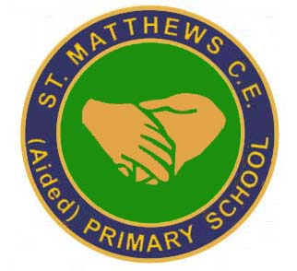
Develop the use of local amenities as a part of History learning.

Class trips will be encouraged, enabling experiential learning for all pupils.
Exploit opportunities for shared expertise between staff.

Ensure opportunities for quality self and peer assessment during history lessons.
The Cornerstones curriculum will continue to be implemented and it’s delivery monitored.

Ensure marking identifies strengths and next steps; reflecting school policy.

Develop greater opportunities for ‘talk’, throughout EYFS, KS1 and KS2.
Develop the use of school artefact boxes, through a thorough resource audit. New resources will be purchased, as appropriate to improve provision for all children.

Develop opportunities to make historical visits to museums and local sites widening the children’s cultural experience and deepening their knowledge and understanding. Use of visitors into school with focused workshops.

Ensure provision within History lessons meets the needs of all pupils.

Ensure differentiation is effective in meeting needs of all pupils.

New resources will be purchased; staff to liaise with co-ordinator to ensure purchases enhance current learning.
Monitor cross-curricular writing opportunities and History provision through book moderations and PDMs.

Ensure teaching inputs are short and relevant through learning walks.

Enhance teaching and learning provision through delivery of Professional Development Meetings, Book Moderations, Learning Walks, Lesson Observations, title pages with cleat knowledge and skill s objectives alongside I know, and I can statements.

Complete a thorough resource audit.

