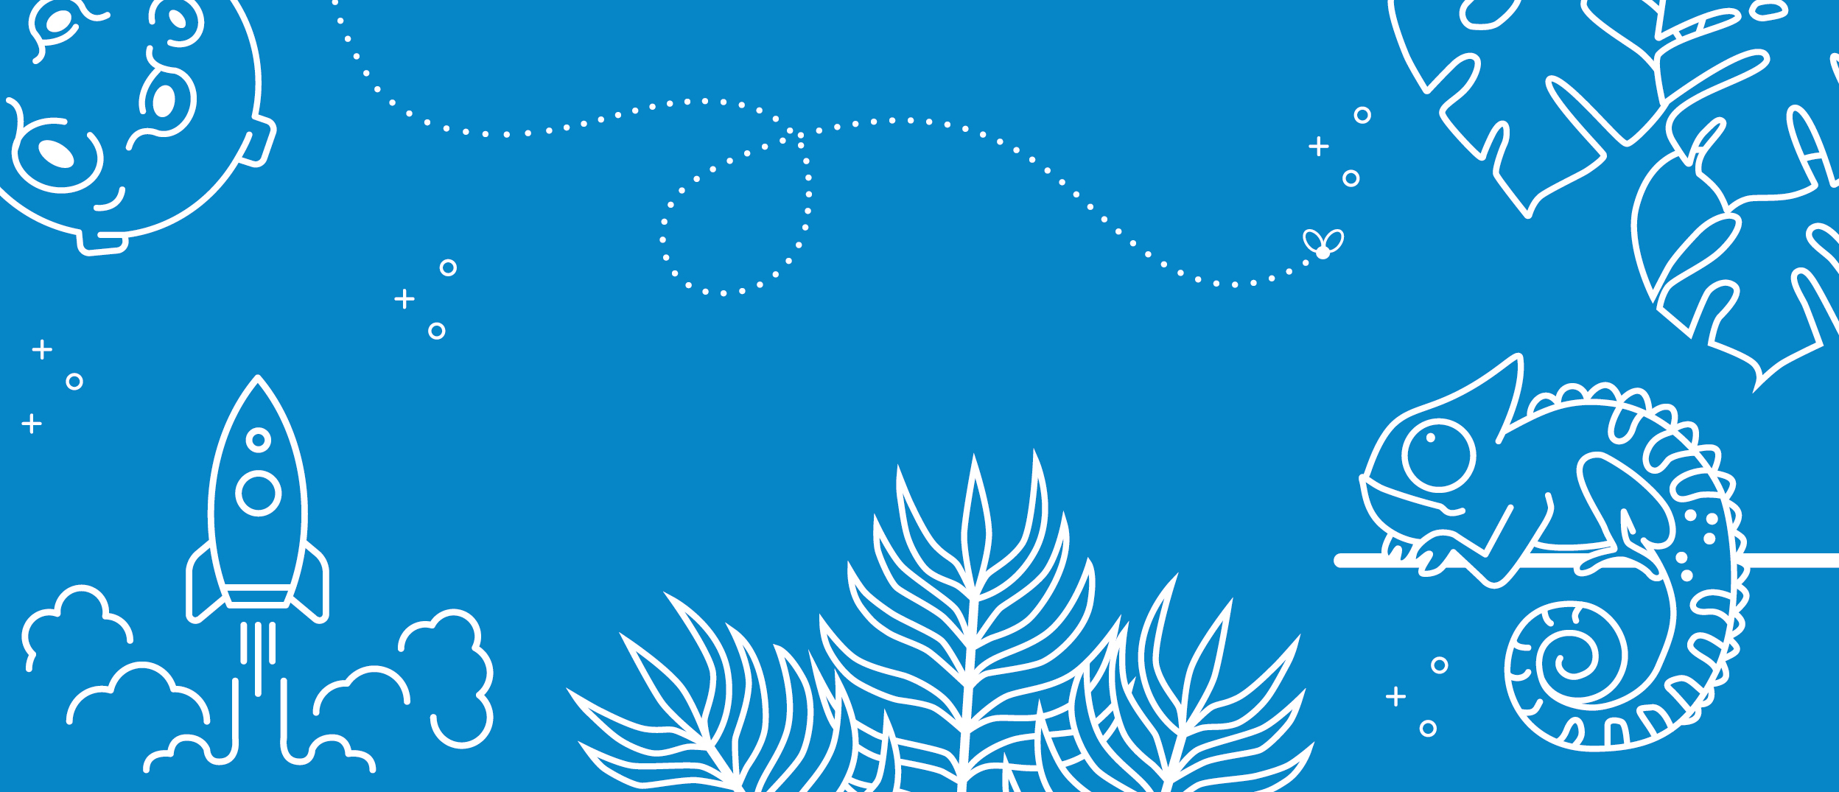

**Ensure teaching staff see the relationship and connection between teaching in science and RSE.**

**Create title pages for each topic, including progression of knowledge of skills.**

**Increase children’s vocabulary capacity and ability to use this in their investigative conclusions.**

**Continue to implement the progression of knowledge and skills through ‘I know’ and ‘I can’ statements which are in line with the national curriculum expectations of learning.**

**Continue to develop children’s voice within science, ensuring all children are encouraged to articulate and justify their ideas.**

**Continue to develop the Science areas and displays throughout school and sections of the website sharing examples of children’s work.**

**To raise standards and expectations of Science through teaching knowledge that can develop into the necessary skills.**

**Complete a thorough and rigorous Science resources audit ensuring that topics taught are resourced thoroughly.**

**To ensure knowledge and skills are clearly distinguishable and planning builds on knowledge that can be applied to skills based activities.**

**Science School Improvement Priorities 2021 - 2022**