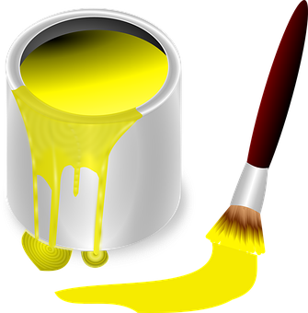

# **School Improvement Priorities 2021/ 2022**

**Art**

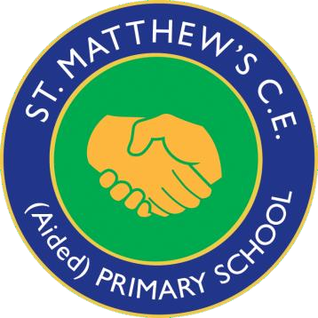

***‘Individuals working to potential together’***

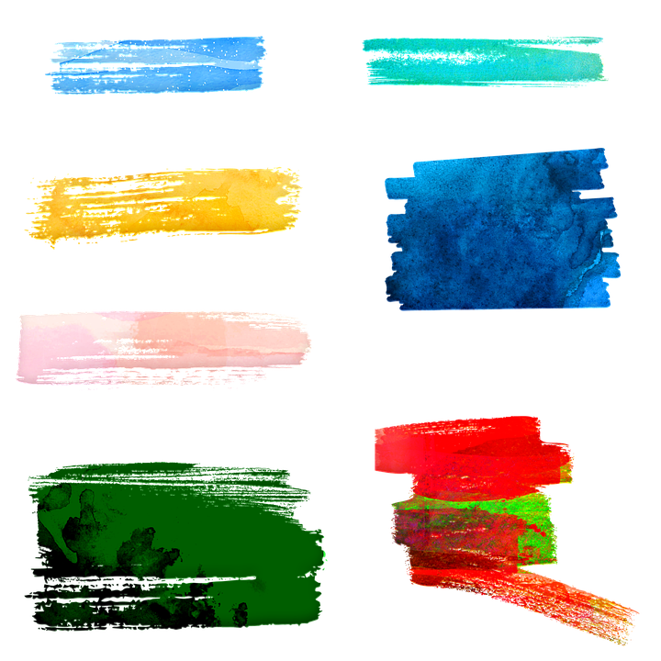

Ensure that children are experiencing a wide range of tools and media



## To monitor the use of sketch books



To raise standards and expectations within art through the teaching of key skills and techniques.



**Collate a portfolio of pupils’ work (recorded, photos etc) which illustrate a strand’s progression**



**Provide in school training for all staff in the use of specialist art equipment**



**Monitor planning and books to ensure Art is being taught throughout a range of subjects.**



**When Art is an area of whole school focus conduct a Deep Dive (conduct a book scrutiny, series of lesson observations, pupil interviews and staff discussion) focusing on progression of skills and knowledge throughout the school.**



**Use I Know and I can statements in children’s learning to demonstrate clear progression in knowledge and skills learnt**



**Amend progression grids, with age-appropriate expectations being listed under the sub-headings of Knowledge and Skills.**