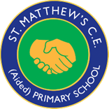
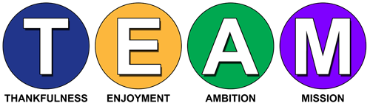
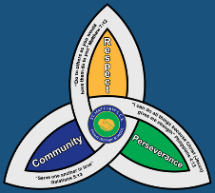

“With God all things are possible.” Matthew 19:26
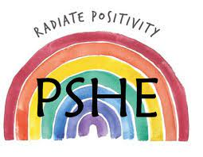
Curriculum Overview and Statement of Intent, Implementation and Impact
Personal, Social, Health and Economic Education
Safeguarding

Safeguarding is at the centre of everything we do at St Matthew’s, we aim to ensure that everyone working in our school understands and adheres to their safeguarding responsibilities. We have a duty of care to all staff, pupils and their families. The safety and protection of all children is of paramount importance to all those involved in education. We are committed to inter-agency working to keep children safe. All of our community believe that our setting does provide a caring, positive, safe and stimulating environment, which promotes the social, physical and moral development of the individual pupil, whilst paying due regard to the protected characteristics of every child.

Equality and Diversity

As a Church of England Aided Primary School, St. Matthew’s school is rooted in Christian values and TEAM spirit, we aspire to be an innovative and inspiring community where every individual is provided with the opportunity to flourish spiritually, morally, emotionally, physically and intellectually. We are ‘Individuals working to potential with God’.
The school is committed to:
- promoting racial equality, good race relations and challenging racial discrimination. This is reflected in all school policies, procedures, processes and practices.
- ensuring that it is a place where everyone, irrespective of their race, colour, ethnic or national origin or their citizenship, feels welcome and valued and able to achieve their full potential.
- protecting the rights of all pupils, staff, parents, governors and visitors to the school.
- respecting and valuing differences between people.
- meeting the diverse needs of pupils.
- preparing pupils for life in a multi-ethnic society.
- acknowledging the existence of racism and being proactive in tackling and eliminating racial discrimination.

Intent  At St Matthew’s Primary school, our school vision is to encourage all children to flourish spiritually, morally, emotionally, physically and intellectually in all aspects of life demonstrating perseverance and resilience; this is emulated across all curriculum areas.  Our intention is that when children leave St Matthew’s, they will do so with the knowledge, understanding and emotions to be able to play an active, positive and successful role in today’s diverse society. We want our children to have high aspirations, a belief in themselves and realise that anything is possible if they put their mind to it. In an ever–changing world, it is important that they are aware, to an appropriate level, of different factors which will affect their world and that they learn how to deal with these so that they have good mental health and well-being.  Our PSHEE curriculum develops learning and results in the acquisition of knowledge and skills which will enable children to access the wider curriculum and prepare them to be a global citizen now and in their future roles within a global community. It promotes the spiritual, moral, cultural, mental and physical development of pupils, preparing them for the opportunities, responsibilities and experiences for later life. Our Relationships and Sex Education enables our children to learn how to be safe, and to understand and develop healthy relationships, both now and in their future lives. | Implementation  EYFS - In the Foundation Stage, PSHEE and citizenship is taught as an integral part of topic work and is embedded throughout the curriculum. The objectives taught are the Personal, Social and Emotional Development statements from ‘Development Matters in the EYFS’ and the PSED Early Learning Goals. Reception also uses the Jigsaw Scheme of Work materials. (see below)  Key Stage 1 and Key Stage 2 - At Key Stage 1 and 2, PSHE is taught through a clear and comprehensive scheme of work in line with the National Curriculum. We ensure we cover the Health and Well-Being, Relationships and Living in the Wider World Learning Opportunities set out in the PSHE Association’s Programme of Study, which comprehensively cover the statutory Health Education and Relationships Education guidance.  Pupils are taught PSHE using ‘Jigsaw’ which is a spiral, progressive scheme of work, covering all the above and 'aims to prepare children for life, helping them to know and value who they are and understand how they relate to other people in this ever-changing world’. There is a strong emphasis on emotional Literacy, building resilience and nurturing mental and physical health. It includes mindfulness to allow children to advance their emotional awareness, concentration and focus.  At St Matthew’s, in addition to Relationships Education, we also teach aspects of Sex Education that is covered in our Science Curriculum. Alongside this we teach about various kinds of relationships, including same sex relationships, and gender identity because it is important that our children should understand the full diversity of the world they live in and be prepared for life in modern Britain. The Sex Education aspects of PSHE are also taught through the ‘Jigsaw’.  PSHEE is taught through Jigsaw’s six half termly themes with each year group studying the same unit at the same time (at their own level):  Autumn 1: Being Me in My World  Autumn 2: Differences (including anti-bullying)  Spring 1: Dreams and Goals  Spring 2: Healthy Me  Summer 1: Relationships  Summer 2: Changing Me (including Sex Education)  It also identifies links to British Values, and SMSC and is taught in such a way as to reflect the overall aims, values, and ethos of the school.  Wider Curriculum  - We believe that focusing on developing a 'Growth Mindset' in our children will help them to build resilience, independence and confidence; embrace challenge; foster a love of learning; and increase their level of happiness. We do this through the language we use in class, praising children for their efforts, and using language to encourage children to change their way of thinking. This supports both our school and PSHE aims and values, and we focus on Growth Mindsets in all aspects of school life.  - PSHE, including SMSC and BV, is an integral part of the whole school curriculum, and is therefore often taught within another subject area.  - Visitors such as emergency services and the school nurse complement our PSHE curriculum to offer additional learning.  - We encourage our pupils to develop their sense of self-worth by playing a positive role in contributing to school life and the wider community. We challenge all our pupils to look for opportunities to show the school values of faith, hope and love.  - Assemblies are linked to PSHE, British Values and SMSC and cover any additional sessions that would benefit the whole school.  - PSHE, BV and SMSC displays throughout school reinforce the PSHE curriculum enabling children to make links. | Impact  By the time our children leave our school they will:  - be able to approach a range of real-life situations and apply their skills and attributes to help navigate themselves through modern life  - be on their way to becoming healthy, open minded, respectful, socially and morally responsible, active members of society  - appreciate difference and diversity  - recognise and apply the British Values of Democracy, Tolerance, Mutual respect, Rule of law and Liberty  - be able to understand and manage their emotions  - be able to look after their mental health and well-being  - be able to develop positive, healthy relationship with their peers both now and in the future.  - understand the physical aspects involved in RSE at an age-appropriate level  - have respect for themselves and others.  - have a positive self esteem

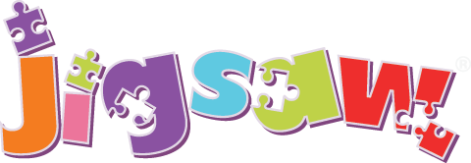
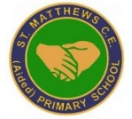
Expect respect and RSE
Ensure that the Expect respect document is embedded across school as well as the new RSE curriculum across all years groups in a cross curricular way.
Commando Jo and karate
Weekly sessions taught by Sensei for all age groups.

Improve home school links
Hold regular meetings and parent shadowing to involve parents in school life such as forest school sessions and family trips. Use a new app in EYFS for parents to contribute to.

Jigsaw
Embed Jigsaw PSHE program across the school and use as part of assemblies. Create whole school display.
PSHE progression
Embed the progression of skills across the school and map out sensitive lessons for teaching and use with HLTAs.

Charity events
Continue to contribute to charity events such as Macmillan coffee morning and Christmas jumper day to support charities.

St. Matthew’s CE (Aided) Primary School and Nursery Centre
School Improvement Priorities
2022/23 PSHE

